A000-EUR-Greece-Horse-Geometric Style-Bronze-850 BCE

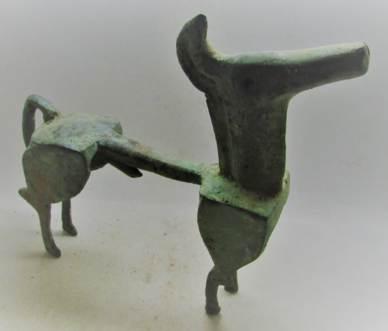

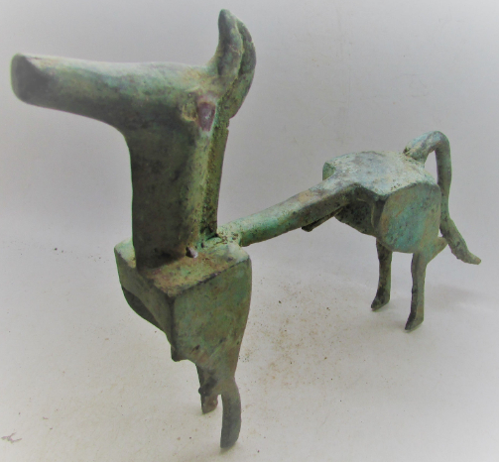

EUR-Greece-Horse-Geometric Style-Bronze-850 BCE

Case no.:4

Accession Number:

Formal Label: EUR-Greece-Horse-Geometric Style-Bronze-850 BCE

**Display Description:**

Geometric Period Greek Art 900 to 700 BCE ushered in a time of dramatic social change leading to the founding of the polis or city-state and colonies in Asia Minor, southern Italy, and Sicily.

The collective body of epic poetry attributed to the twelfth c BCE poet, Homer, was gathered together, describing the Greek campaign against Troy (the Iliad) and Odysseus’ Ithaca homecoming (the Odyssey which provided a new appreciation for the previously lost Homeric past. Grave goods included metal objects of copper, tin, and gold, precious metals that were not indigenous to Greece. Most Greeks were sedentary agriculturists according to Hesiod (639–40), but mounted heroic warriors were also in the background as weapons and geometric bronze horses like this very rare example have been found in cemeteries.

LC Classification: DF221.5

Date or Time Horizon: 750 BCE

Geographical Area:

Map:

GPS Coordinates:

Cultural Affiliation: Geometric Greece

Medium: Bronze

**Dimensions**:   
**Weight:**

**Provenance**:

**Condition:**

**Discussion:**

**References:**

Coldstream, J.N., 2004. *Geometric Greece: 900–700 BC*. Routledge.

Garland, Robert. The Greek Way of Death. Ithaca, N.Y.: Cornell University Press, 1985.

Hornblower, Simon, and Antony Spawforth, eds. The Oxford Classical Dictionary. 3d ed., rev. New York: Oxford University Press, 2003.

Langdon, Susan, ed. From Pasture to Polis: Art in the Age of Homer. Exhibition catalogue. Columbia: University of Missouri Press, 1993.

Lawrence, A. W. Greek Architecture. 4th ed., rev. by R. A. Tomlinson. Harmondsworth: Penguin, 1983.

Padgett, J. Michael, ed. The Centaur's Smile: The Human Animal in Early Greek Art. Exhibition catalogue. Princeton: Princeton University Art Museum, 2003.

Pedley, John Griffiths. Greek Art and Archaeology. 2d ed. New York: Harry N. Abrams, 1998.

Schweitzer, Bernhard. Greek Geometric Art. New York: Phaidon, 1971.

Appendix:

# “The statuette, dating from the eighth century BC and given an estimate of $150,000 to $250,000, was due to have been sold in Sotheby’s New York salerooms on May 14 with other sculptures from the Barnets’ collection. One of the highlights of the auction, the stylised horse from the Geometric Period was featured on the cover of the catalogue.” From “Sotheby’s takes Greece to court in antiquities test case,” [***https://www.ft.com/content/e8c59de8-68cd-11e8-8cf3-0c230fa67aec***](https://www.ft.com/content/e8c59de8-68cd-11e8-8cf3-0c230fa67aec) *29 Nov. 2018*.